

2017 MALAWI SCHOOL CERTIFICATE OF EDUCATION EXAMINATION

MATHEMATICS
(100 marks)

PAPER I
Subject Number: M131/II
Thursday, 30th March Time Allowed: 2 hours
08:00 – 10:00 am

MOCK

Instructions
Question  Number | Tick if  answered | Do not write in these columns

1

2

3

4

5

6

7

8

9

10

11

12

13

14

15

16

17

18

19

20

21

22

23

24

- This paper contains 13 printed pages. Please check.
- Write your Names at the top of each page.
- Answer all the twenty four questions in the spaces provided.
- The maximum number of marks for each answer is indicated against each question.
- In the table provided on this page, tick against the question number you have answered.
- At the end of the examination, hand in your paper to the invigilator.

© 2017 UNIQUE EXAMS Turn over
- Factorize the following expression completely:
$a^{2} \left(a -1\right) –$a $+$1

(3 marks)

- Given that $y= \frac{1}{3} x -3$and $y= \left(a-\frac{2}{3}\right)x+5$are the equations of two parallel lines. Find the value of “a”.

(4 marks)

- Find the Matrix M which satisfies the equation $\left[\begin{matrix}2 & 1 \\ 0 & 3\end{matrix}\right]-$2M =$\left[\begin{matrix}1 & 1 \\ 2 & 0\end{matrix}\right]$.

(3 marks)

- In figure 1 below are triangles in which angle BAC = 60º and angle BCD = 45º.
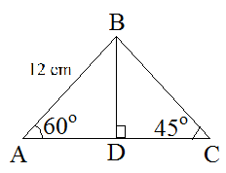
Figure 1
Calculate the length of DC. Leave your answer in surd form.

(4 marks)
- Triangle ABC and XYZ are similar. The sides of triangle ABC are 6cm, 7cm and 8cm. the shortest side of angle XYZ is 2cm. Given that the area of triangle XYZ is 4.5 cm², calculate the area of triangle ABC.

(4 marks)
- In a plastic bag there are x blue pens, 6 black pens and 4 red pens. If the probability of picking a red pen is $\frac{1}{5} ,$calculate the number of blue pens.

(4 marks)
- In figure 2, TP is a tangent to the circle APB at P and AB is parallel to PT.
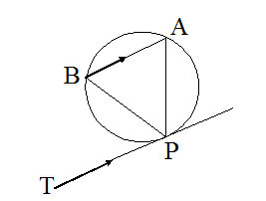
Figure 2
Prove that AP = BP.

(4 marks)
- Given that$g\left(x\right)=\frac{1}{1 - x}$ , find the value of “a” if$g\left(3-a\right)=\frac{2}{3}$.

(3 marks)
- Solve the equation $\log_{5}\left(x-1\right)+\log_{5}{3=-1.}$

(4 marks)
- P is a set of point (x, y) which satisfies the three inequalities.
$x≥0$
x$+$ y $≤4$
y $≥x+1$

Show on a graph the region represented by P. (Using a scale of 2cm to represent 1 unit on the x-axis and y-axis).
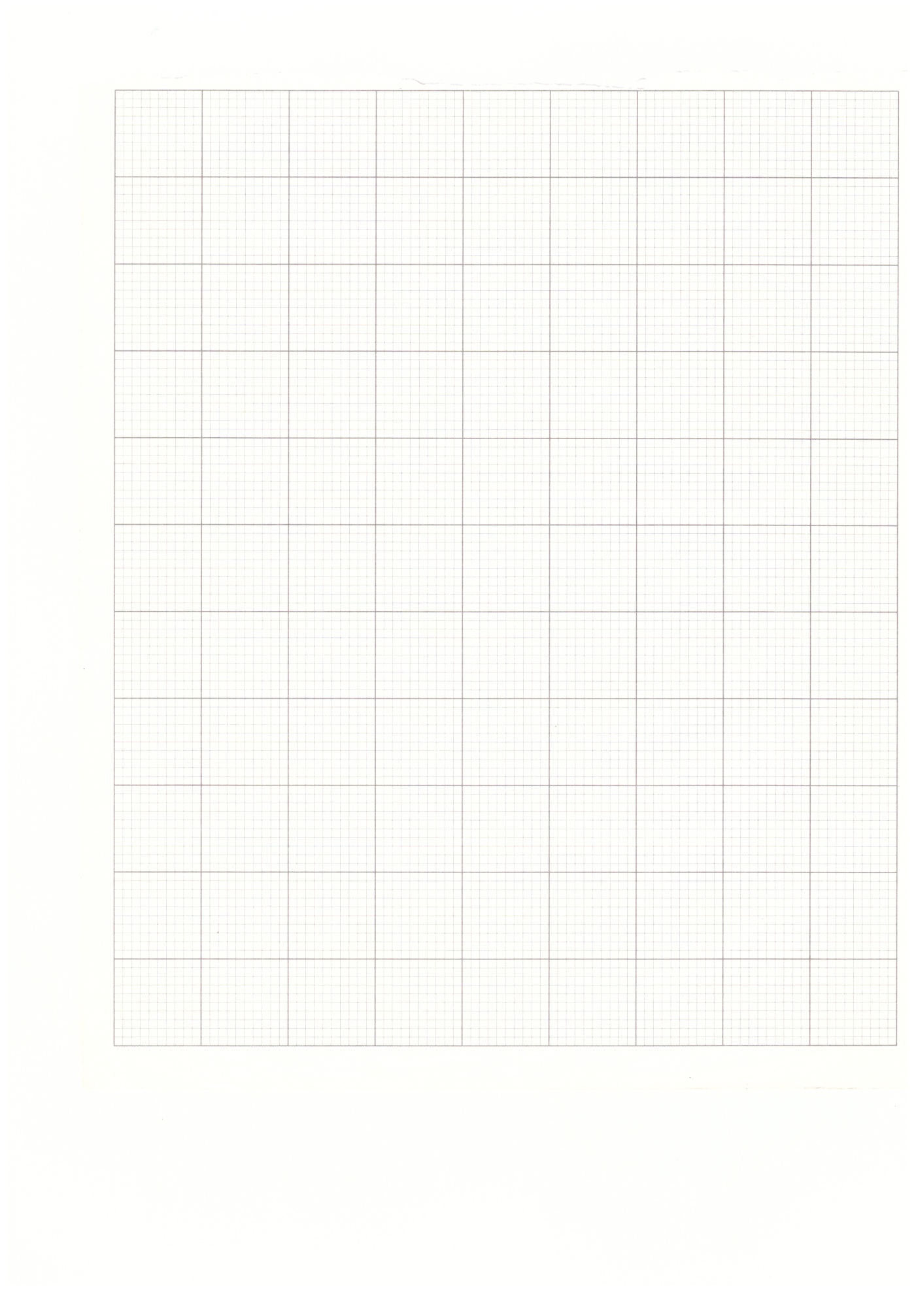
(5 marks)
- Figure 3 is a speed-time graph for a particle during the 20 second of its motion.
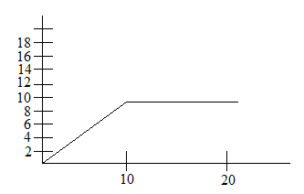
Figure 3
Calculate the particle’s average speed during the 20 seconds.

(4 marks)
- In figure 4, O is the center of the circle, angle ADC = 60º and BC is parallel to AD.
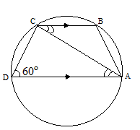
Figure 4
Find the value of angle ACB.

(4 marks)
- Given that sin x =$\frac{\sqrt{3}}{2}$, evaluate:
$\frac{\tan{x+\cos{x}}}{\tan{x-\cos{x}}}$

(5 marks)

- The first, tenth and last terms of AP are 3,$16$ $\frac{1}{2}$ and 361$\frac{1}{2}$ in that order. Calculate the number of terms in the series.

(5 marks)
- If $x^{2}+$ x$-$2 is a factor of $x^{3}+{ax}^{2}+$ $bx+6$, find the values of “a” and “b” and hence the remaining factor.

(5 marks)
- Solve for x if ${ (2^{x})}^{ 2 }- 9(2^{x}) + 8 = 0$.

(4 marks)

- Figure 5 shows an arrow diagram for the function g$\left(x\right)$ $=$ $\frac{2}{x-2}$
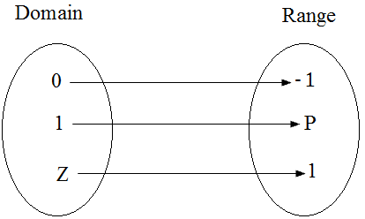
Figure 5

Calculate the value of P and Z.

(4 marks)
- The quantity p varies directly as the square of q and inversely as r. When $p=18$, $q=6$ and $r=30.$ Find r when $p=27$ and $q=12$.

(4 marks)
- Make m the subject of the formula
$r = \frac{n}{\sqrt[3]{k - m}}$

(4 marks)
- Figure 6 shows a curved graph.
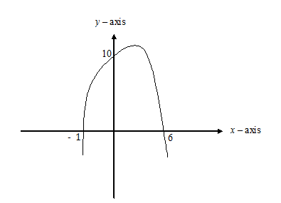
Figure 6
Find the equation of the curve in the form y =${ax}^{2}$ + bx + c.

(4 marks)

- Solve the following simultaneous equations:
$$x - y =5$$
$x^{2}$ + xy +$y^{2}$ = 7

(5 marks)

- In figure 7, O is the centre of the circle. XP and XQ are tangents to the circle at A and B respectively and angle AXB=58º.
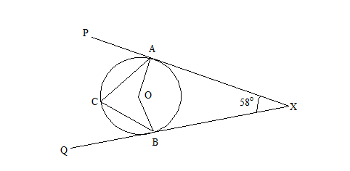
Figure 7
Calculate angle ACB

(4 marks)
- Evaluate ${36}^{- \frac{1}{2}}-\log_{x}{x}+ y^{0}.$

(4 marks)

- ACB is a triangle in which $A=(-1, -1), B=\left(2, -1\right)$ and T =$\left(\begin{matrix}2 \\ - 2\end{matrix}\right).$ Find the vertices of the image of ABC under translation 2T.

(6 marks)

END OF QUESTION PAPER
“Simple Things Are Very Very Simple But Not Easy”
Edited by
Cassim Ibrahim (Mr. Simple Things)

